Housing prices in the Podkarpackie

This report determines the average price per square meter of flats in the Podkarpackie region. The time period covers the years from **2017** to **2021** broken down into quarters.

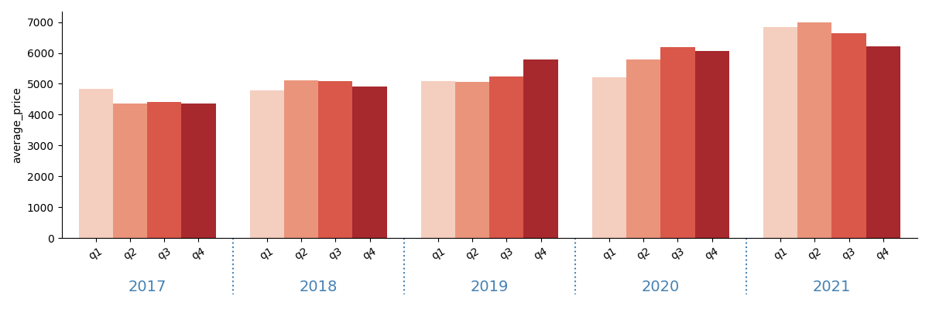

The highest price was PLN 6991 in Q2 2021. In subsequent periods, average prices were lower. The lowest price was PLN 4354 in Q4 2017.

In the first period under review, the price was PLN 4838, while in the last period the price was PLN 6222. The price in the analyzed period increased by PLN 1384.

The biggest change in price between the quarters under study occurred between Q4 2020 and Q1 2021. The value in this period increased by PLN 765.

Average price and number of sold apartments

The chart shows the ratio of the average price of flats per 1 m2 to the number of flats sold. As the starting index, the first analyzed period, 2017 Q1 = 100%.

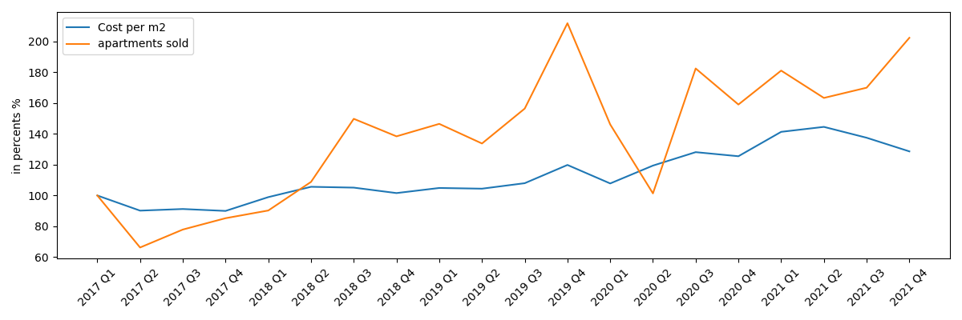

In the analyzed period, the decrease or increase in the sale of flats most often had the opposite effect on the price of flats per 1 m2.